Project Features: Analog Input and Digital Output.
Program an Arduino board to accept an analog input voltage and display the magnitude of the voltage using a 10 LED display.

Input voltage = 0% of maximum (all LEDS off)
Input voltage = 30% of maximum
Input voltage = 70% of maximum
Document your program and include the following sections. Provide a brief description of the system and how you are designing it to operate.

A. Hardware Diagram:
Provide a hardware diagram of the components.

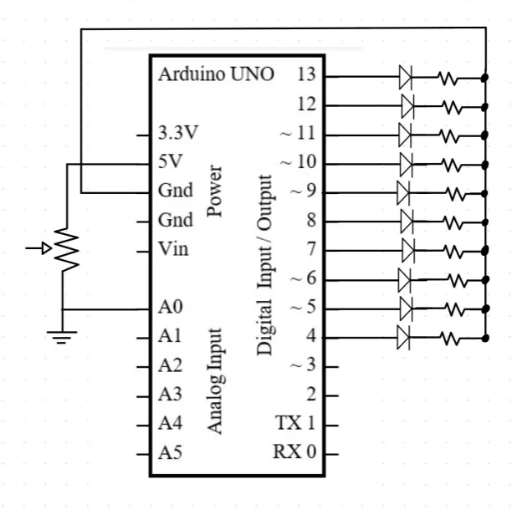

B. Program Flowchart:
Draw a flowchart of the program.
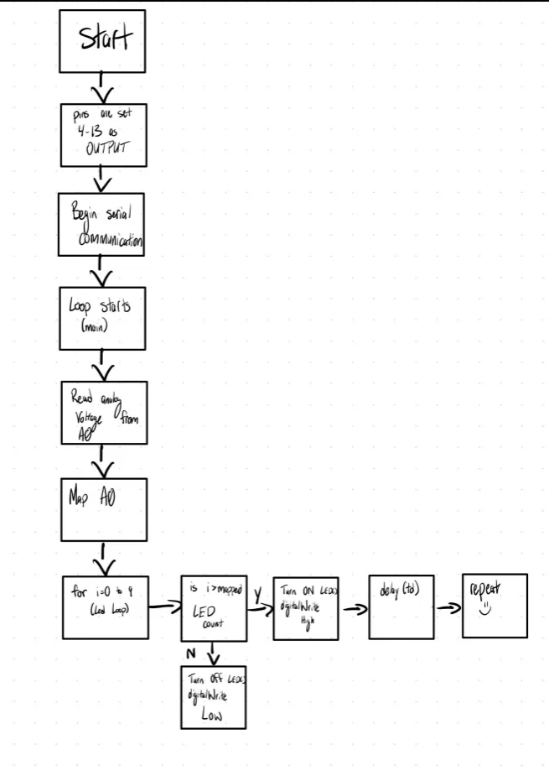

C. Arduino Source Code
Insert the Arduino Source Code into the document.

// Digital VU Meter - ECE 2305 Hardware Project 03

const int td = 100;
int analogVoltage = 0;

void setup() {
for (int pin = 4; pin <= 13; pin++) {
pinMode(pin, OUTPUT);
}
Serial.begin(9600);
}

void loop() {
analogVoltage = analogRead(A0);
Serial.println(analogVoltage);

int ledCount = map(analogVoltage, 0, 1023, 0, 10); // Map analog input to 0-10 LEDs

for (int i = 0; i < 10; i++) {
if (i < ledCount) {
digitalWrite(4 + i, HIGH); // Turn on LEDs up to ledCount
} else {
digitalWrite(4 + i, LOW); // Turn off the rest
}
}

delay(td);
}

D. Demonstration Video
Record and upload a video demonstrating the operation of the circuit.
DONE
Save the document as a PDF file and submit the PDF document to Blackboard.

